CYBERQUOTE PTE LTD

Sales Performance Management
Phase III

Program Design Specification
- Call Report

For: | CYBERQUOTE PTE LTD | Project Ref: | PM1103
Author: | Thet Su Mon | Doc Ref: | SpmPhaseIII-TS-PS-Call Report -1.0
Proj Mgr: | Ei Ei Thu | Version: | 1.0
Date: | 14/10/2011 | Classification:
To : |  | Cc:

Document Revision History

Document Title :

Version | Revised by | Effective Date | Summary of Change | Reason for change
1.0 | Thet Su | 14/10/2010 | New Document | -

Table of Contents

1 Program Definition 3
1.1 System Name 3
1.2 Program Description 3
1.3 Programming Language/Version 3
1.4 Drivers Required/Version 3
2 Structure Design 3
2.1 Block Chart or Flow Chart on top level structure of the program 3
2.1.1 Presentation Layer 3
2.1.2 Web Service Layer 4
2.2 Description of each module 5
2.2.1 Presentation Layer 5
2.2.2 WebService Layer 6
2.3 Description of Stored Procedures used 7
3 Input/Output files used 7
3.1 Input/Output file format design (with Samples attached) 7
3.2 Database connections used 7
4 Error Message/Warning Message List 7
5 Program List 7
6 Acceptance Form 8

Program Definition

System Name
Sales Performance Management (hereinafter referred as SPM) system Phase III

Program Description
This is the program design specification of “Call Report” function which is defined under “Call Report” in the design specification.

Programming Language/Version
This program will be developed in C# using Visual Studio 2008 for running under ASP.net 3.5.

Drivers Required/Version
The ASP.NET AJAX 1.0 is required to support Ajax in ASP.NET environment.

Structure Design

Block Chart or Flow Chart on top level structure of the program

Presentation Layer
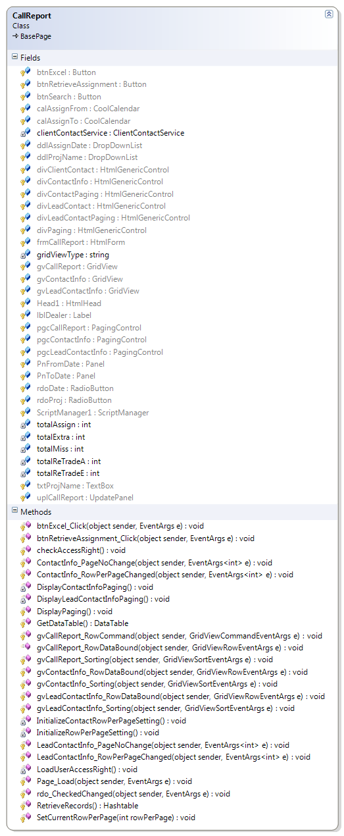
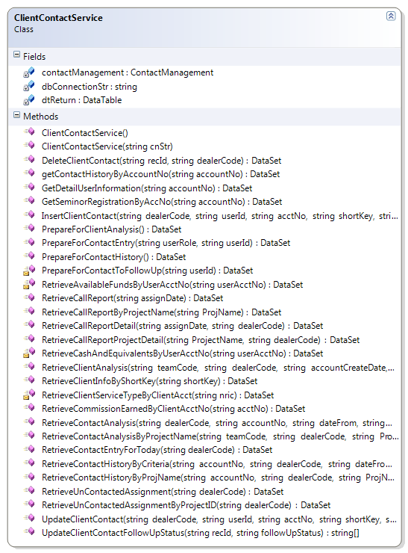

Web Service Layer
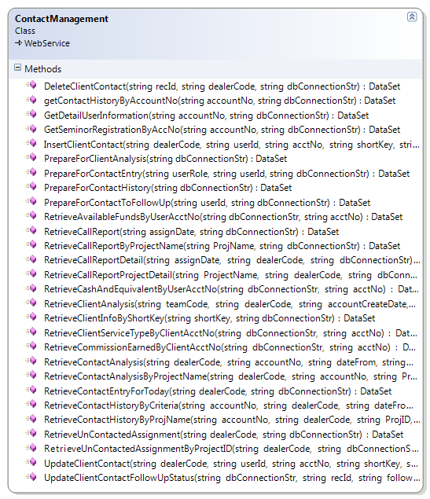
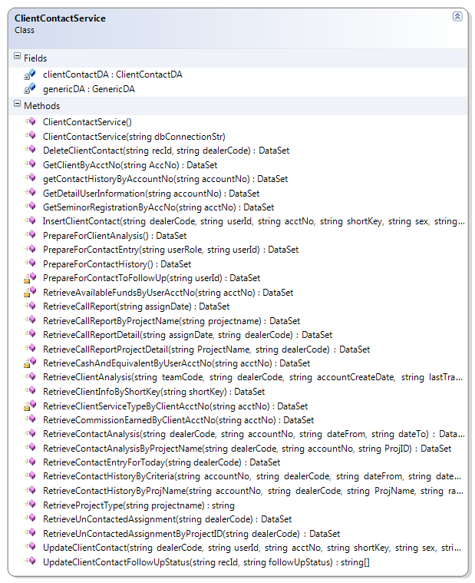

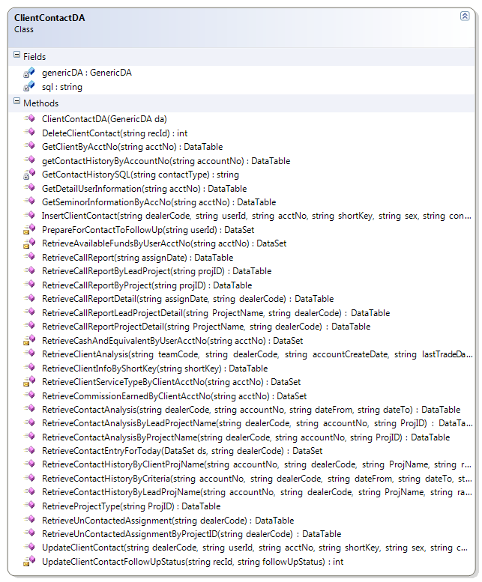

Description of each module

Presentation Layer

CallReport.aspx.cs
Member | Description
Fields
clientContactService | Control for accessing web service layer
totalAssign | Total assignment count for each dealer.
totalMiss | Total miss call count for assignment.
totalExtra | Total extra call count for assignment.
totalReTradeA | Total re-trade count after assigned for assignment.
totalReTradeE | Total re-trade count after extra call for assignment.
gridViewType | To use for generating excel report.
Methods
Page_Load | Retrieve and construct user dropdown list
LoadUserAccessRight | Retrieve the User access right.
CheckAccessRight | Check the access right and enable or disable the button according to the access right.
ContactInfo_PageNoChange | User shall be able to change page no.
ContactInfo_RowPerPageChanged | Use to display paging user control after assignment records retrieved from database.
LeadContactInfo_PageNoChange | User shall be able to change page no for lead contact detail.
LeadContactInfo_RowPerPageChanged | User shall be able to set the rows count per page.
rdo_CheckedChanged | To enable or disable the calendar or drop down list.
PrepareForAssignmentHistory | Set Assign Date From value to one week from current date and Assign Date to value to current date. Retrieve and construct dealers dropdownlist.
RetrieveRecords | Retieve call report for user selected assign date by calling clientContactServiceRetrieveCallReport() method;  Construct gridview to show assignment records.
InitializeRowPerPageSetting | Set default values for paging user control.
InitializeContactRowPerPageSetting | Set default values for paging user control.
DisplayContactInfoPaging | Display the page links depend on the current page.
DisplayLeadContactInfoPaging | Display the leadcontact info page links depend on the current page.
DisplayPaging | Use to display paging user control after assignment records retrieved from database.
SetCurrentRowPerPage | Call from BasePage class to store current row per page in viewstate for paging control whenever user change the value.
GetDataTable | Call from BasePage class to get data to display whenever user change the page no (or) row per page.
btnRetrieveAssignment_Click | Retrieve assignment date for users to use in generating call report.
btnExcel_Click | Generate excel file for retrieved assignment records.
gvCallReport_RowDataBound | Calculate total assignment count, miss called count, extra call count, re-trade after assign count and re-trade after extra call count.
gvCallReport_RowCommand | Retrieve client contact detail for user selected dealer.
gvCallReport_Sorting | Sorting the records by clicking the heading link.
gvContactInfo_RowDataBound | Display client miss call as red color and client extra call as brown color.
gvContactInfo_Sorting | Sorting the records by clicking the heading link.
gvLeadContactInfo_RowDataBound | Display leads miss call as red color and leads extra call as brown color.
gvLeadContactInfo_Sorting | Sorting the records by clicking the heading link.
SetCurrentRowPage | User set the rows count per page.

ClientContactService.cs
Member | Description
Fields
dbConnectionStr | Database connection string
contactManagement | Reference of the assignment management web service
dtReturn | Return Data table
Methods
ClientContactService | Constructor: to create contact management web service instance
ClientContactService(string cnStr) | Constructor: get database connection from caller after ClientContactService() constructor
RetrieveCallReport | Retrieve call report for user selected assignment date.
RetrieveCallReportByProjectname | Retrieve call report for user selected client or lead project name.
RetrieveCallReportDetail | Retrieve client contact record for user selected dealer.
RetrieveCallReportProjectDetail | Retrieve client contact record for user selected dealer by user selecting with the project name.

WebService Layer

ContactManagementService.asmx.cs
Member | Description
Methods
RetrieveCallReport | Retrieve call report for user selected assignment date.
RetrieveCallReportDetail | Retrieve client contact record for user selected dealer.
RetrieveCallReportByProjectName | Retrieve call report for user selected client or lead project name.
RetrieveCallReportProjectDetail | Retrieve client contact record for user selected dealer by user selecting with the project name.

ClientContactService.cs
Member | Description
Fields
clientContactDA | Data access layer for client assignment services
dtReturn | Return datatable
GenericDA | Generic data access layer
returnCode | Return Code  1 – Successful  -1 – Failed
returnMessage | Return message
Methods
ClientContactService | Constructor: to create generic data access and client assignment data access instance
ClientContactService(string cnStr) | Constructor: get database connection from caller after ClientContactService() constructor
RetrieveCallReport | Retrieve call report for user selected assignment date.
RetrieveCallReportDetail | Retrieve client contact record for user selected dealer.
RetrieveCallReportByProjectName | Retrieve client or lead call reports for selected user project name.
RetrieveCallReportProjectDetail | Retrieve client contact record for user selected dealer by user selecting with the project name.
RetrieveProjectType | To retrieve the project type.

ClientContactDA.cs
Member | Description
Fields
GenericDA | Generic data access layer
sql | Sql statements
Methods
RetrieveCallReport | Retrieve call report for user selected assignment date.
RetrieveCallReportByProject | Retrieve client call report for user selected project name.
RetrieveCallReportByLeadProject | Retrieve leads call report for user selected project name.
RetrieveCallReportDetail | Retrieve client or leads contact record for user selected dealer.
RetrieveCallReportProjectDetail | Retrieve client contact record for user selected dealer.
RetrieveCallReportLeadProjectDetail | Retrieve Leads contact record for user selected dealer.
RetrieveProjectType | To retrieve the project type.

Description of Stored Procedures used
None

Input/Output files used
None

Input/Output file format design (with Samples attached)
N/A

Database connections used
BasePage.dbConnectionStr

Error Message/Warning Message List
Message | Cause
Call report not found! | No matched record is found for user entered search criteria.
Error in retrieving call report! Please try again. | When system failed to retrieve call report records.
Problem in WebService Connection! | When system failed to call web service
Please retrieve Assignments/Projects first before searching Call Report. | User not select the Assignment date or project name then clicking the search button.
No records to generate Excel File! | When user click the excel button, no records to generate.

Program List
SPMWebApp\Services
ClientContactService.cs

SPMWebApp\WebPages\ContactManagement
CallReport.aspx
CallReport.aspx.cs
CallReport.aspx.designer.cs

SPMWebServiceApp\WebServices
ContactManagement.asmx
ContactManagement.asmx.cs

SPMWebServiceApp\Services
ClientContactService.cs

SPMWebServiceApp\DataAccess
ClientContactDA.cs

Acceptance Form

Project Name : | Sales Performance Management Phase II
Document Name : | Program Design Specification – Call Report  (Doc Ref: SpmPhaseII-TS-PS-Call Report-1.0)
Company Name : | CyberQuote Pte Ltd
Project Manager : | Li Qun
Designation : | Snr Consultant
Signature/Date :

